**Redes de Comunicação 2020/2021**

**Relatório da meta intermédia**

**Alexandre Andrade – 2019220216**

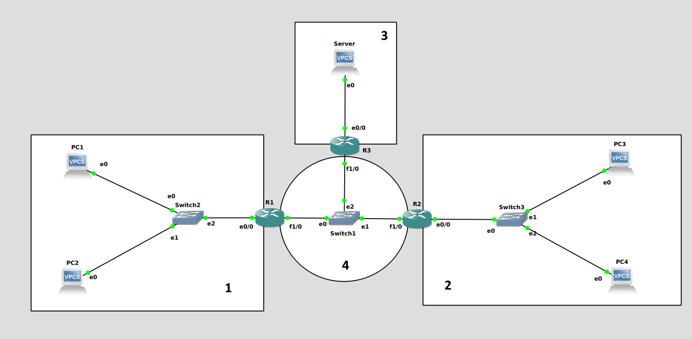**Tomás Mendes – 2019232272**

**2**

Network – 193.136.212.192/27

* **R2** – 193.136.212.222/27
* **PC3** – 193.136.212.193/27
* **PC4** – 193.136.212.194/27

**1**

Network – 193.136.212.128/26

* **R1** – 193.136.212.190/26
* **PC1** – 193.136.212.129/26
* **PC2** – 193.136.212.130

~

**3**

Network – 10.90.0.0/24

* **R3** – 10.90.0.245/24
* **Server** – 10.90.0.1/24

**4**

Network – 193.136.212.224/29

* **R1** – 193.136.212.225/29
* **R2** – 193.136.212.226/29
* **R3** – 193.136.212.227/29

**Comandos de configuração:**

**R1:**

conf t

interface e0/0

ip address 193.136.212.190 255.255.255.192

no shut

exit

interface f1/0

ip address 193.136.212.225 255.255.255.248

no shut

exit

ip route 193.136.212.192 255.255.255.224 193.136.212.226

exit

**R2:**

conf t

interface e0/0

ip address 193.136.212.222 255.255.255.224

no shut

exit

interface f1/0

ip address 193.136.212.226 255.255.255.248

no shut

exit

ip route 193.136.212.128 255.255.255.192 193.136.212.225

exit

**R3:**

conf t

interface e0/0

ip address 10.90.0.254 255.255.255.0

ip nat inside

no shut

exit

interface f1/0

ip address 193.136.212.227 255.255.255.248

ip nat outside

no shut

exit

ip route 193.136.212.128 255.255.255.192 193.136.212.225

ip route 193.136.212.192 255.255.255.224 193.136.212.226

access-list 1 permit 10.90.0.0 0.0.0.255

ip nat inside source list 1 interface f1/0 overload

ip nat inside source static tcp 10.90.0.1 80 193.136.212.227 80

exit

**PC1:** ip 193.136.212.129/26 193.136.212.190

**PC2:** ip 193.136.212.130/26 193.136.212.190

**PC3:** ip 193.136.212.193/27 193.136.212.222

**PC4:** ip 193.136.212.194/27 193.136.212.222

**Server:** ip 10.90.0.1/24 10.90.0.254

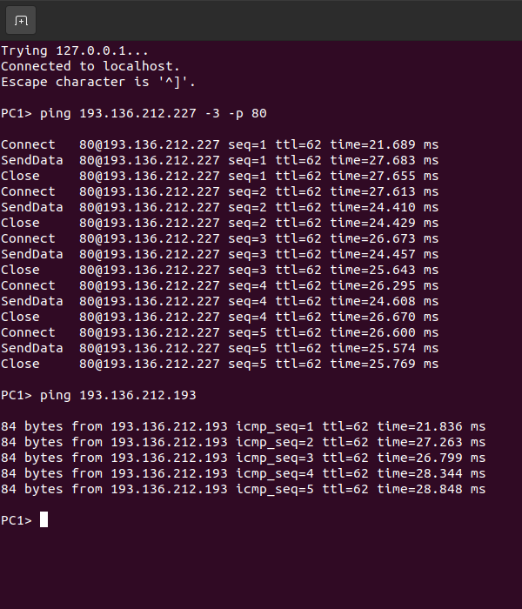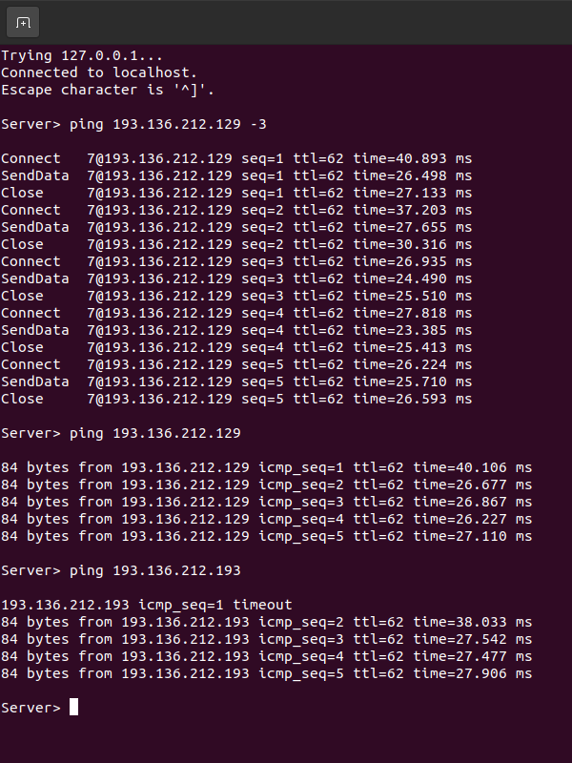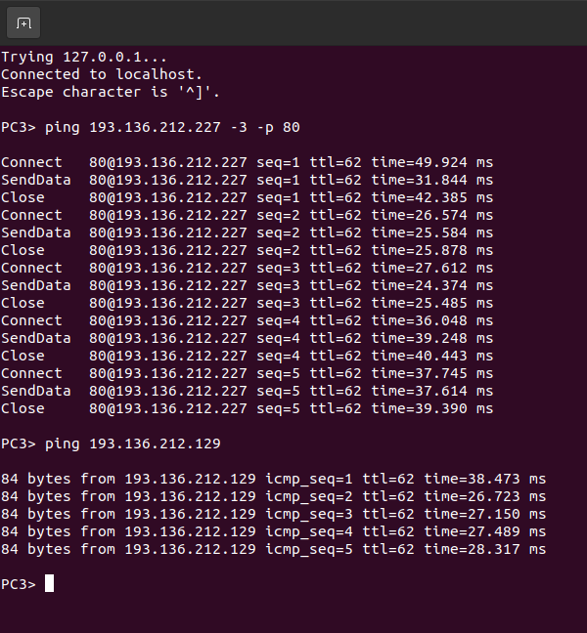**Ping PC1 –> (PC3 e Server) Ping PC3 –> (PC1 e Server) Ping Server –> (PC1 e PC3)**

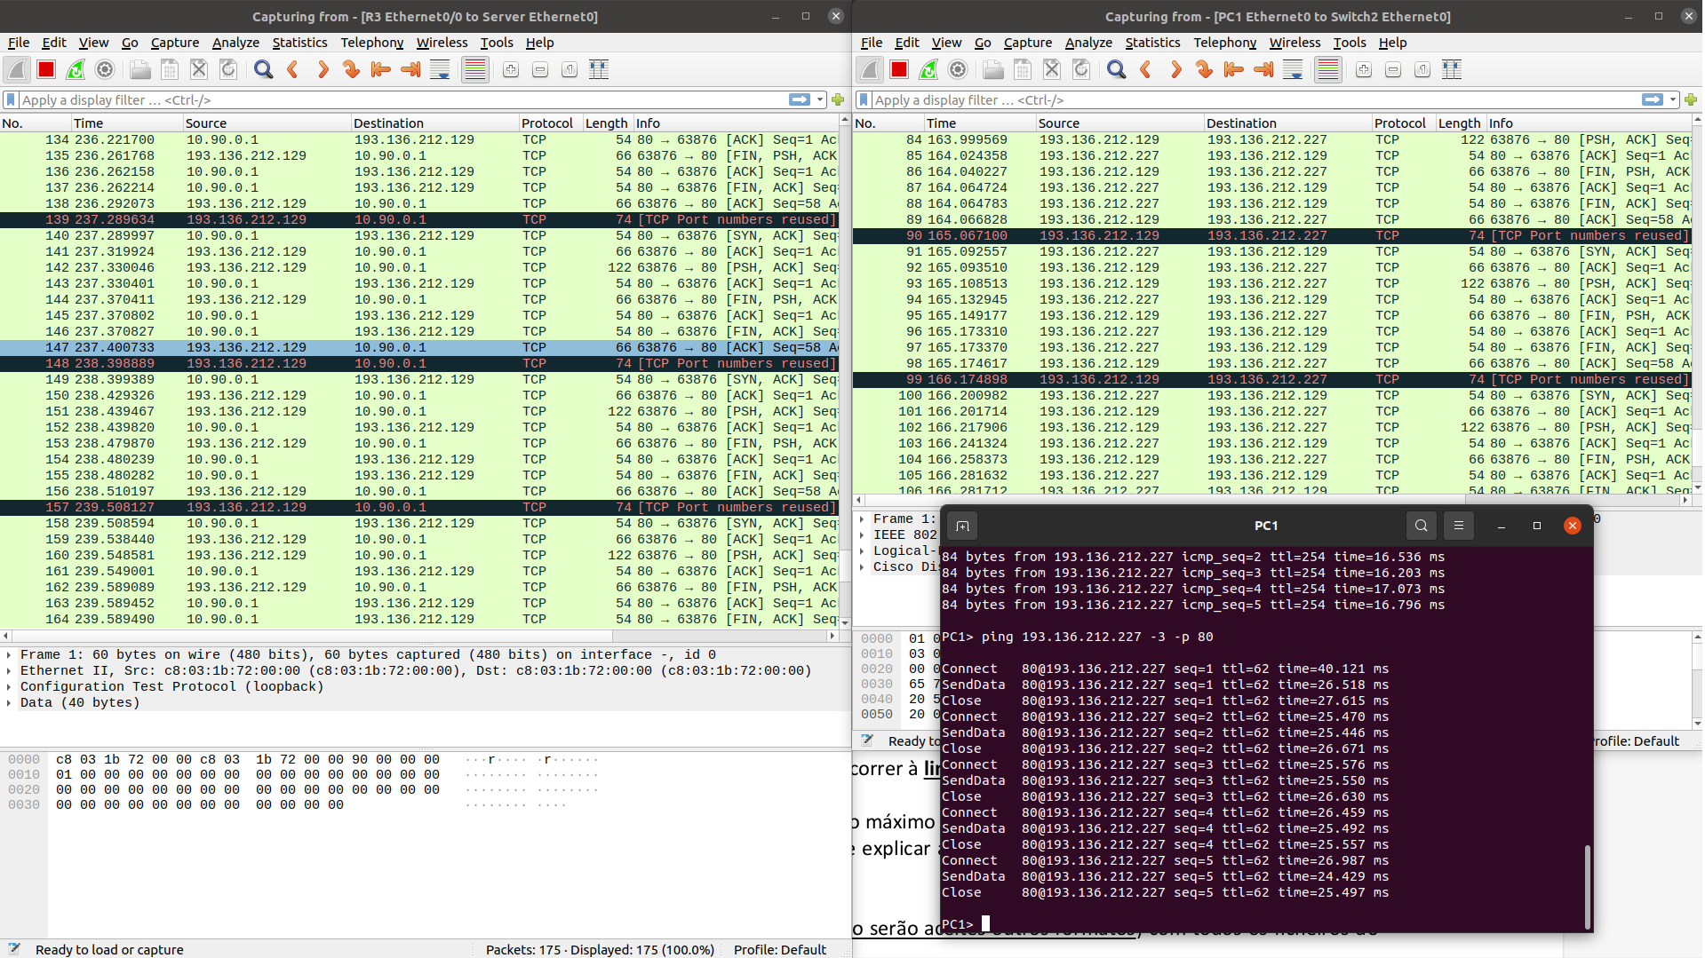**Teste DNAT**

**Teste SNAT**